The pupil reflex

You are going to work in pairs and investigate the pupil reflex of the eye with your partner.

Method

1. Look carefully at the pupil (dark area) of one of your partner’s eyes and draw its shape on the first eye below.
2. Your partner now covers up that eye with their hand for about 30 seconds.
3. Your partner then removes the hand from their eye. Look immediately at the pupil and draw its shape on the second eye below.
4. Then look at your partner’s pupil about 10 seconds after the hand was removed and draw its shape on the bottom eye.

Results

*a b c*

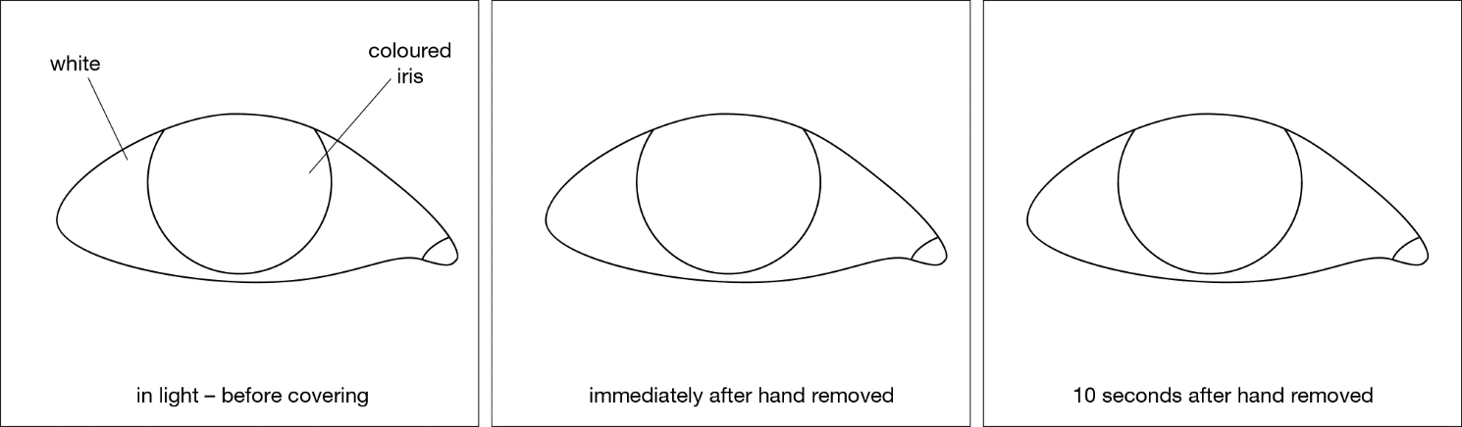

Conclusion

Complete the sentences below.

In diagram **a** the pupil is small to limit the amount of light entering the eye. This prevents the retina  
from being damaged by bright light.

In diagram **b** the pupil is _____________________________________________________

This is because ____________________________________________________________

_________________________________________________________________________

In diagram **c** the pupil is _____________________________________________________

This is because____________________________________________________________

_________________________________________________________________________

This is an example of a cranial reflex. Nerve impulses travel from the eye to the brain and back.

Even though the nerve cells (neurones) go to the brain, there is no thinking involved.

Questions

1. How do you know there is no thinking involved in this action?

_______________________________________________________________________

_______________________________________________________________________

_______________________________________________________________________

_______________________________________________________________________

1. A reflex action is automatic. What does automatic mean?

_______________________________________________________________________

_______________________________________________________________________

_______________________________________________________________________

_______________________________________________________________________

1. Reflex actions are to protect you. How does this pupil reflex protect you?

_______________________________________________________________________

_______________________________________________________________________

_______________________________________________________________________

_______________________________________________________________________

_______________________________________________________________________

1. Blinking is another example of a reflex action. How does this reflex protect you?

_______________________________________________________________________

_______________________________________________________________________

_______________________________________________________________________

_______________________________________________________________________

_______________________________________________________________________